Self-Balancing Robot (Inverted Pendulum on Wheels)
IDEA
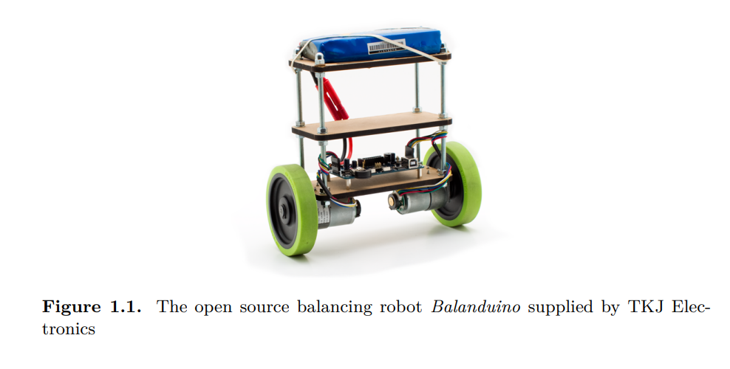
How it works
- An IMU sensor (accelerometer + gyroscope) measures the robot’s tilt angle
- A Kalman filter (or complementary filter) fuses the sensor data for a clean angle estimate
- A PID controller computes motor corrections in real time to keep it balanced
- Two DC motors with encoders drive the wheels accordingly
- (Optional) Full LQR state-space controller
Suggested Stack
Component | Suggested Part | Approximate Cost
Microcontroller | Arduino | R80 – R150
IMU | MPU-6050 (6-axis) | R60 - R100
Motor Driver | L298N Dual H-Bridge | R60 - R90
DC Gear Motors (x2) | With encoders, 6V-12V | R200 – R400
Wheels (x2) | 65 mm rubber wheels | R60 – R120
Chassis | Laser-cut acrylic or 3D printed | R150 – R300
Battery | 2S LiPo or 4x AA pack | R100 – R200
Misc. (wiring, standoffs, switches) | --- | R100 – R150
Total |  | ~R810 – R1510

Leaving room to add Raspberry Pi for data logging, a Bluetooth module for tuning PID gains wirelessly, or even an LCD to display live sensor values.
Where to buy
- Micro Robotics (Stellenbosch)
- Communica (Paarden Eiland)
- RS Components SA (Online)
- DigiKey South Africa (Online)
Milestones
- Get the IMU reading – wire up the MPU-6050, read raw data, implement a complementary filter to get a clean tilt angle.
- Drive the motors – test the H-bridge, get basic forward/back working
- Close the loop – implement a basic P controller first, observe instability, then add I and D terms
- Tune the PID – this is where the fun (and frustration!) is
- Stretch goal – implement an LQR controller and compare performance to PID
External Links
- https://www.instructables.com/Self-Balancing-Upside-Down-Pendulum/
- https://www.shaysackett.com/inverted-pendulum-robot/
- https://www.diva-portal.org/smash/get/diva2:916184/FULLTEXT01.pdf
- https://youtu.be/jP7Y_BfuGDI?si=Myiii08xSY3t1dM1 - Balancing robot tips video.
Objectives
- Get it to balance “horizontally”.
- Get it to balance “vertically”.
- Implement cascaded PID loop (velocity = 0).
- Try to implement LQR?
VERSION HISTORY
Idea is to do a prototype with version 2 and then upgrade the motors to version 3.
Version | Description of Change
v1 | First draft
v2 | Changed to DRV8833 motor driver

VERSION 2
COMPONENTS
MPU-6050
- https://youtu.be/rpCcZZJeodY?si=zEn9Rm8-psDM20C_ - YouTube video.
- https://forum.arduino.cc/t/getting-started-with-the-mpu6050-beginner-friendly-guide-with-visual-explanations/1364064 - Arduino forum explanation (other useful links).
- https://www.electronicwings.com/sensors-modules/mpu6050-gyroscope-accelerometer-temperature-sensor-module - Communica link.
Arduino
- Nano or Mega (probably Mega as it will make a better body “shape”). Going to use Uno (correct size and I am familiar with it).
Motor Driver
- DRV8833 (see link below).
- https://www.communica.co.za/products/hkd-ramps-stepper-driver-drv8833?variant=40351922618441&sfdr_ptcid=31591_617_692972130&sfdr_hash=f1fc32f8c8e4b23f0e60c33591a415d0&utm_source=www.communica.co.za&gad_source=1&gad_campaignid=22552818411&gbraid=0AAAAADLTnIZTVU6Cje37BAAegSC4YUWFZ&gclid=CjwKCAjw8arQBhB9EiwAfIKdQvWFYp-EkF1O7b7p8GFMhgPHTlYBra40T-tZbtKAcBej18Wki_dD6hoCPh4QAvD_BwE.
- Adafruit themselves recommend the DRV8833 motor driver for these motors, as it works well down to 3V and can handle the maximum current of the motors.
- https://youtu.be/cBS9IGJ8LQc?si=vVlXfKhfLhNzHTyi – DRB8833 tutorial.
- Motor voltage 2.7 V to 10.8 V, continuous current 1.2 A and peak current 2 A per motor.
- DRV8833 Pin explanation:
Pin | Purpose
EEP | Puts device in sleep mode (0V = sleep, 5V = On) (Enabled by default due to J1)
Output 1 and Output 2 | Connects to Motor A
Output 3 and Output 4 | Connects to Motor B
ULT | Fault pin (Goes low if error, floats normally)
Input 3 and Input 4 | Set one high and one low to control Motor B direction
GND | Ground (must ground to Arduino ground and battery-)
VCC | Connect to positive terminal of battery
Input 1 and Input 2 | Set one high and one low to control Motor A direction (digitalWrite)

DC Gear Motors (x2)
- What motors to use? Standard ones from Micromouse project.
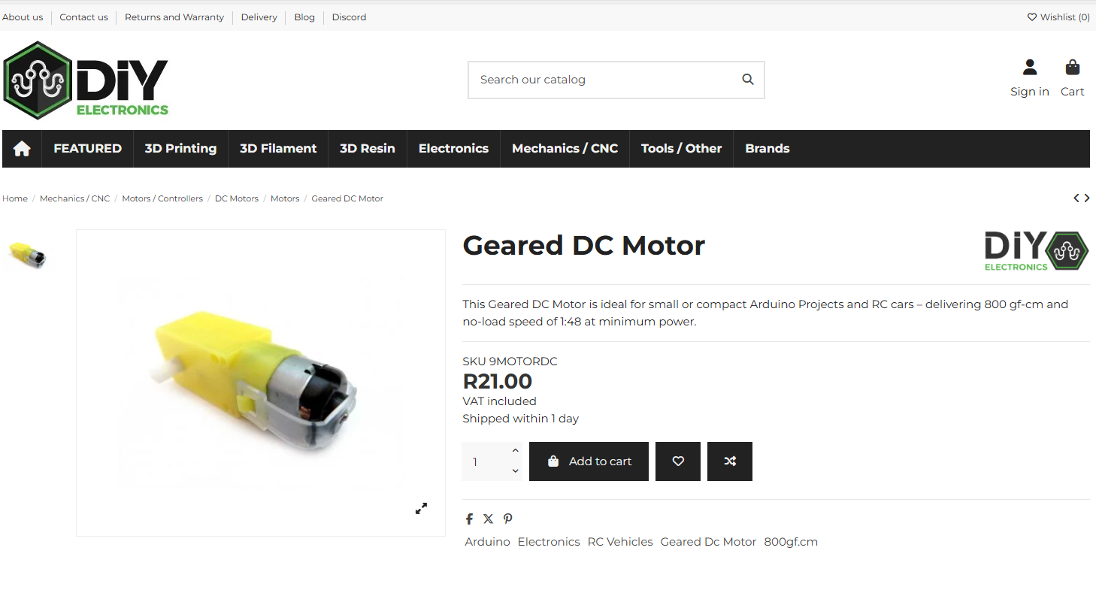
Wheels
- Standard wheels we used for micromouse (see below).
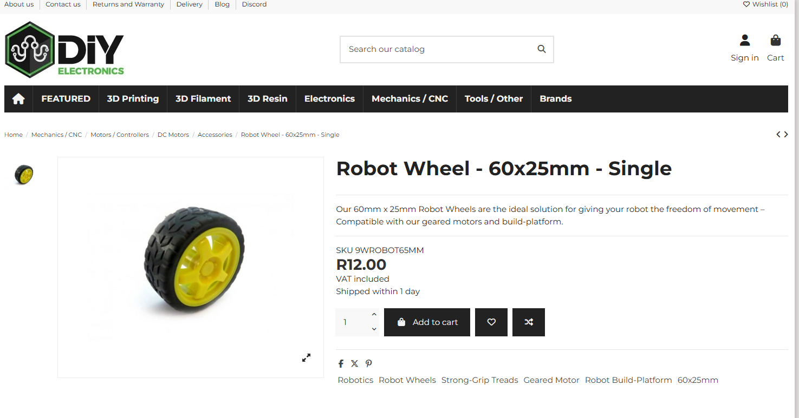
- If struggling with control, larger wheels (diameter) can improve stability.
Chassis
- 3D print?
- Use breadboard?
- Will try and use breadboard and Arduino together directly connected to motors. Possibly both need to be put on small wooden board.
Battery
- Can power from laptop to start (only motors will need batteries).
- https://www.robotics.org.za/603450 - 7.4V battery.
- Will need a charging circuit too.
- https://www.robotics.org.za/DFR0564 - Battery charger circuit (USB).
- Do I need JST PH connector to connect to breadboard (something like below)? I think so.
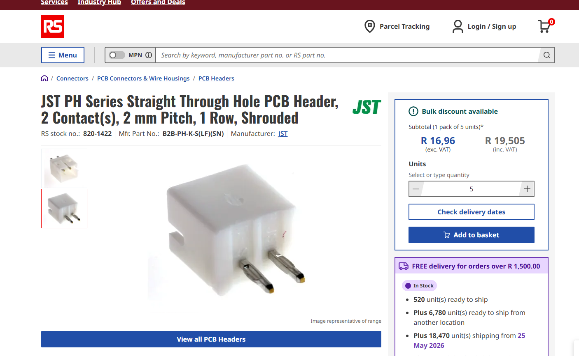
- https://www.communica.co.za/products/xy132-02st - Communica version.
Potentiometers
- https://www.robotics.org.za/index.php?route=product/category&path=25_327 – general page.
- https://www.robotics.org.za/WH148-10K - cheaper option and pack of four.
Switch
- Needs to be 12 V, 1 A rated.
- Must be DC.
- Ideally fits in a breadboard.
- https://www.robotics.org.za/KBT001129-BLU
Other
- Nice small breadboard with multiple dividers? See below link.
- https://www.communica.co.za/products/bmt-breadboard-8-3x5-5cm-400tp?variant=52114451857708&sfdr_ptcid=31591_617_756176052&sfdr_hash=bb756a0b0dccbe2ed9b1a7c65af875e6&utm_source=www.communica.co.za&gad_source=1&gad_campaignid=20668254388&gbraid=0AAAAADLTnIbzvEAdrt-ixEG3Gu6-UzOf6&gclid=CjwKCAjw8arQBhB9EiwAfIKdQkSSMzc7uims97IhZc9b69lC9DkFK7bfecUCEdPY-fcZT8k1Mxqk8hoCdSUQAvD_BwE.
- Nice connectors.
SCHEMATIC / CONNECTION DIAGRAM
- Table and diagrams here to track how many pins I need / what is connected to what.
Component | Connects To
MPU-6050
VCC | Arduino 5V
GND | Arduino GND
SCL | Arduino SCL
SDA | Arduino SDA
DRV8833
EEP | ---
Out 1 | Motor A
Out 2 | Motor A
Out 3 | Motor B
Out 4 | Motor B
ULT | ---
IN 4 | Arduino Digital Output Pin
IN 3 | Arduino Digital Output Pin
GND | Battery- and Arduino GND
VCC | Battery+
IN2 | Arduino Digital Output Pin
IN1 | Arduino Digital Output Pin
Arduino Uno has 14 digital pins (labelled 0 to 13). This should be plenty.
VOLTAGE & CURRENT ANALYSIS
Device | Voltage
Battery Output | 7.4 V
Arduino Voltage Input | 7 V to 12 V (Vin Pin)
Arduino Digital Output Pins | 5 V
Motor Driver Input Voltage | 2.7 V to 10.8 V
DC Motors | 3 V to 6 V
Motor Driver Output | 7.4 V – 0.12 V = 7.28 V (must use PWM)
MPU6050 Voltage Supply | 3 V to 5 V
** Motors will see roughly 7.28 V. Must drive DRV8833 with PWM signal so that it receives approximately 5 V. Measure with multimeter!
Current
Device | Current
DC Motors @6V no-load | 160 mA
Driver Continuous Current Limit | 1.2 A (per motor)
DC Motors @6V when stalled | 1.5 A
Driver Peak Current Limit | 2 A (per motor)
MPU6050 Current Draw | 3.9 mA to 5.1 mA
Arduino Uno 5V Pin Current Limit | 800 mA
Arduino Digital I/O Pins | 20 mA (40 mA absolute max)
10k Potentiometer | 0.5 mA
** Peak motor driver current is not exceeded. MPU6050 and Potentiometers can be powered from standard Arduino Digital Output pin.
BILL OF MATERIALS
Component | Price | Quantity | Total | Link
Arduino Uno | R139 | 1 | R139 | Communica
Breadboard | R15 | 1 | R15 | Communica
MPU6050 | R60 | 1 | R60 | Communica
JST-Connector | R0.4 | 3 | R1.2 | Communica
Female Header | R3.39 | 2 | R6.78 | Communica
DRV8833 | R25 | 1 | R25 | Communica
Communica Total |  |  | R202.98
Geared DC Motor | R48.26 | 2 | R97 | Digikey
Robot Wheel | R73.62 | 1 | R74 | DigiKey
Male Connectors | R31.90 | 1 | R31.90 | DigiKey
Button | R4.91 | 5 | R24.55 | DigiKey
DigiKey Total |  |  | R227.45
Battery | R129 | 1 | R129 | Microrobotics
Battery Charger | R109 | 1 | R109 | Microrobotics
Potentiometer | R23 | 1 | R23 | Microrobotics
Switch | R16.10 | 1 | R16.10 | Microrobotics
Microrobotics Total |  |  | R277.10
Total |  |  | R726.98

SOFTWARE
Complementary Filter vs Kalman Filter
- Both are sensor fusion algorithms used primarily to combine gyroscope and accelerometer data. The main difference is that a Complementary Filter is a simple, computationally light, heuristic approach, whereas a Kalman Filter is an advanced, probabilistic method that dynamically adjusts based on noise and uncertainty.
Complementary Filter
- Implementation goes here.
Kalman Filter
- Can try Complementary first and maybe improve with Kalman later.
- https://youtu.be/DQw4cNx9wdw?si=WBi8i-YrmZRtg9gD - Kalman Filter Video.
Motor Driver
- analogWrite(pin, value)
- Pin must be a PWM-capable pin (marked with ~ symbol)
- Value: an integer from 0 to 255 (0 means 0 V or 0 % duty cycle and 255 means 5 V or 100 % duty cycle)
- If it receives 7.4 V from the battery, a duty cycle of 81% will give an effective voltage of 6 V.
- I.e. a value of 207
- Measure to make sure!
Control Algorithm
- COM angle is the reference you want to set it to?
- Two nested PID loops?
Notes
- Whatever you do, keep the Gyro as close to the middle of the axle as possible and lay it flat with the pins sticking up. don't mount the Gyro halfway up or you will get an error with your readings.
QUESTIONS
- Ask Claude if my planned set up will work – Only potential issue is RPM range of current motors (200 rpm). Most successful projects use higher speed motors (e.g. 300 to 500 rpm range). Shouldn’t be impossible but will make PID tunning more difficult (Tips and tricks video uses this motor).

